LM-35 :

The LM35 is a precision integrated-circuit temperature sensor whose output voltage is linearly proportional to temperature in °C.
The LM35 measures temperature by producing a voltage that increases linearly with temperature. Internally, it uses transistor behavior affected by temperature and outputs 10 mV/°C without any extra processing needed.

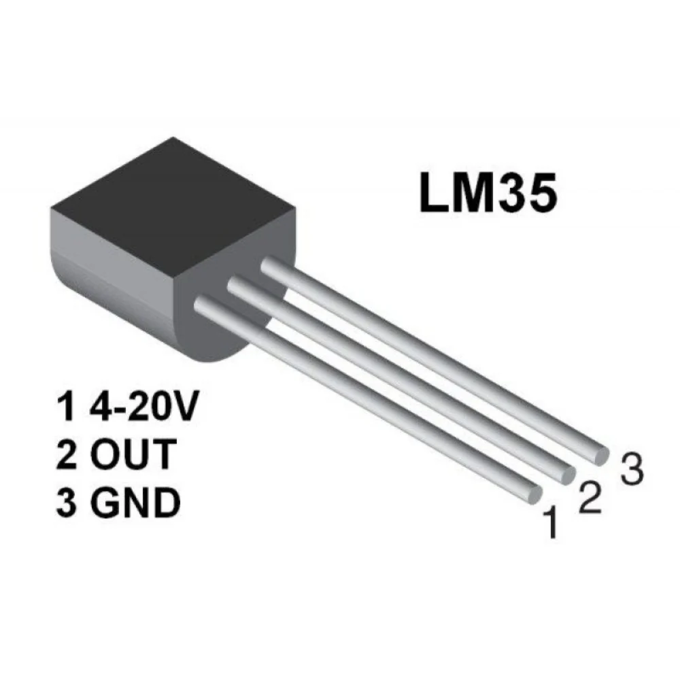
Key Features
- Direct calibration in Celsius (°C)
- Linear output: 10 mV/°C
- High accuracy: ±0.5°C at 25°C
- Operating temperature range: −55°C to +150°C
- Low power consumption: < 60 µA current drain
- Low self-heating: only 0.08°C in still air
- Operates on 4V to 30V supply
- Available in TO-92, SOIC-8, TO-220, TO-46 packages

Pin Configuration

Pin | Name | Description
1 | +VS | Positive supply (4V–30V)
2 | VOUT | Analog output (10 mV/°C)
3 | GND | Ground

Electrical Characteristics
Parameter | Typical Value
Output at 0°C | 0 mV
Output at 25°C | 250 mV
Output at 100°C | 1.00 V
Accuracy at 25°C | ±0.5°C
Slope | 10 mV/°C
Quiescent Current (at 5V) | 56 µA
Max Output Current | 10 mA
Output Impedance | ~0.1 Ω

Typical Application Circuit
- Supply voltage: 4–30V
- Output connected to analog input of a microcontroller

Thermal Performance
- Junction-to-ambient thermal resistance (TO-92, still air): 180°C/W
- Self-heating is minimal, <0.1°C

Applications :
- Power supplies : To monitor and protect power electronics from overheating.
- Battery management systems : Used in battery-operated systems to prevent thermal runaway and improve battery life.
- HVAC (Heating/Ventilation/Air Conditioning) : For environmental temperature monitoring and control in smart buildings.
- Home Appliances : Embedded in ovens, refrigerators, washing machines, and air conditioners for temperature regulation.
- Industrial temperature control
- Remote weather monitoring

